**Morphing Leadership Model**

**Overview**

According to Socrates, "the secrete of change is to focus all of your energy not on fighting the old but on building the new." As I reflect on my career and executive leadership journey, working with others to build transformative change in communities and individual lives has been a common thread that connects my professional experiences. The value of helping others and solving complex community issues shapes how I nurture relationships, partner with others, and lead. Identifying the root causes of community challenges, engaging key stakeholders, collecting data, piloting ideas, and adjusting strategies as you learn is not a linear process but an iterative one. These realities create the foundation of the Morphing Leadership model I created and enhanced throughout my DEL journey.

Much like butterflies that undergo different stages to complete their transformation, the morphing model focuses on the stages that an individual will navigate to contribute to and ultimately implement the desired transformative outcome. This model also establishes a framework of the strategies and practices that must collectively be in place to have the desired community impact. Therefore, *The Morphing Leadership Model* is a continuously evolving individual development process that parallels the model's four key components to drive transformative community impact.

**Leadership Development Stages**

An essential part of leadership development is understanding oneself. Understanding one's values and character provide a lens into how you react to ethical issues and challenges and shape how you make a decision (Tichy & Bennis, 2009). It is also essential to have a level of curiosity to drive the learning and sensemaking of the decision-making process (Horstmeyer, 2020). Self-awareness of your strengths, areas of improvement, preferences, style of work, and learning inform the leader of their blindspots and where they best can contribute to accomplishing the strategic vision and ultimately leading successfully. The Morphing Leadership Model accounts for this process to be actively occurring as the leader is working to understand the challenges of the communities they are seeking to help and then collaborate with key stakeholders and community leaders to design innovative solutions that can positively 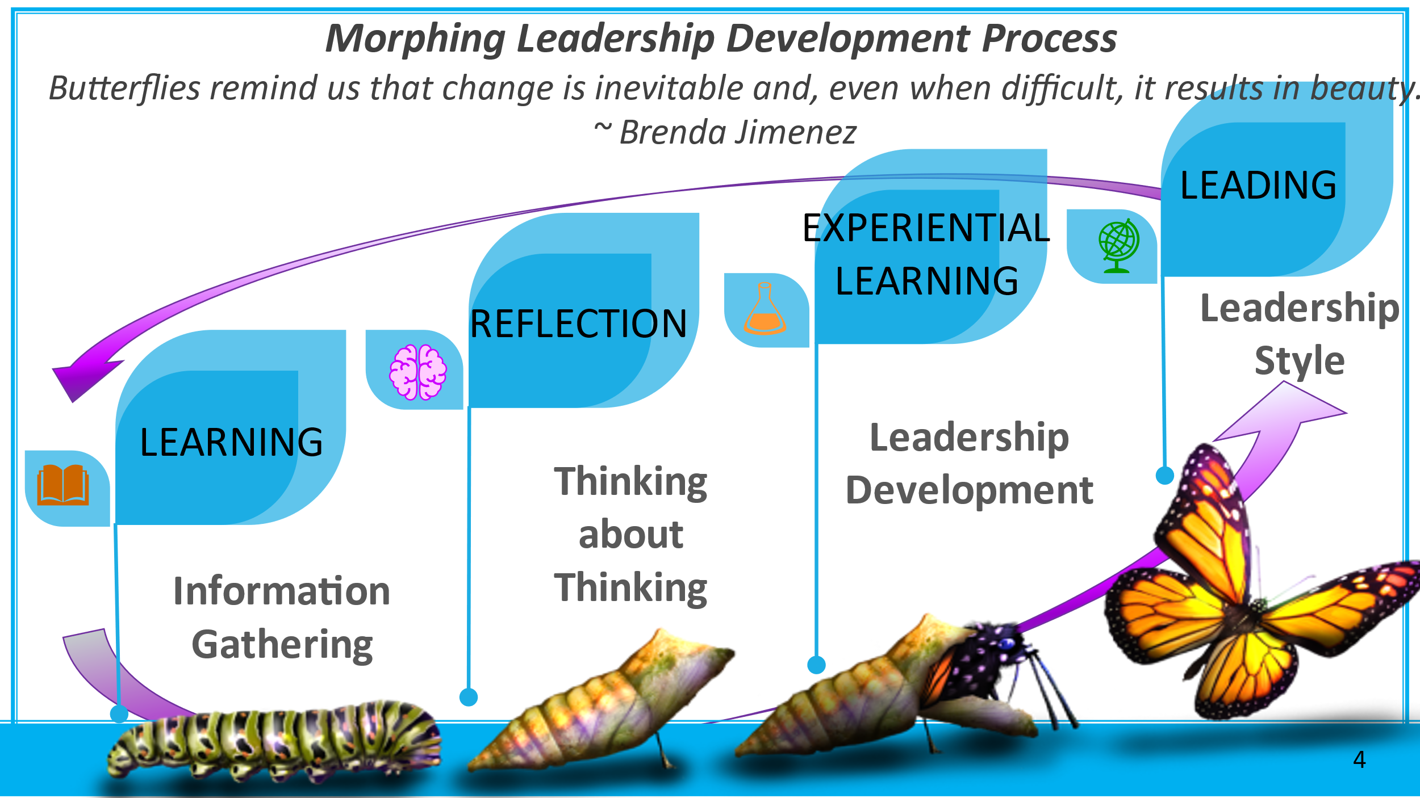transform the community and its members.

The four leadership development stages include learning, reflection, experiential learning, and leading.

***Learning:*** collecting data that informs experiences and allows inferences and connections to be made when navigating different situations. This process is essential to becoming a scholar-leader and understanding the constructs of your personality, emotional intelligence, and preferred styles that shape how you see and react to the world. The habits of the mind, like listening, understanding, empathy, and thinking flexibility, are vital to understanding different perspectives, shifting one's thinking, and getting in tune with your judgments (Costa, 2008).

***Reflection:*** Thinking about thinking allows the individual to develop strategy, address complex problems, and explore ideas. A leader's reflection process is an opportunity to wonder, explore questions, and be creative. (Costa, 2008).

***Experiential Learning:*** According to Ashford and DeRue(2012), 70% of leadership development occurs as people go through the ups and downs of challenging, developmental experiences on the job. Seeking those opportunities and developing mentoring relationships to support this growth is necessary,

***Leading:*** Once you have gone through this process, you can test your learning and experiences and make tweaks as you provide leadership. Mindful Engagement during this process that pulls from the individual's knowledge and experiences will support Identifying the approach, action, and next steps you anticipate having to take.

This development process is a continuous cyclical learning process as the leader engages in the *Morphying Model* with stakeholders and the community. Knowing one's self and understanding our followers is key in this process. Gardner (2013) identifies a leader's ability to understand their followers' needs as a key factor in their effectiveness. He states that the "leader who would succeed, then, is the one who bests senses and delivers what an audience already desires" (2013, p.16).

**Morphing Leadership Model in Action**

Solving complex issues within a community can be very challenging and require a long-term strategy that is continuously evaluated and adjusted to meet the needs of the evolving circumstances. Engaging the right stakeholders from diverse backgrounds and expertise from inside and outside the community helps inform the data collected and the innovation and strategies developed. To honor the individuals you ultimately want to help, you must have them actively involved in the process and provide feedback to have changes institutionalized and embedded in the culture of the community. This leadership model considers this reality in its 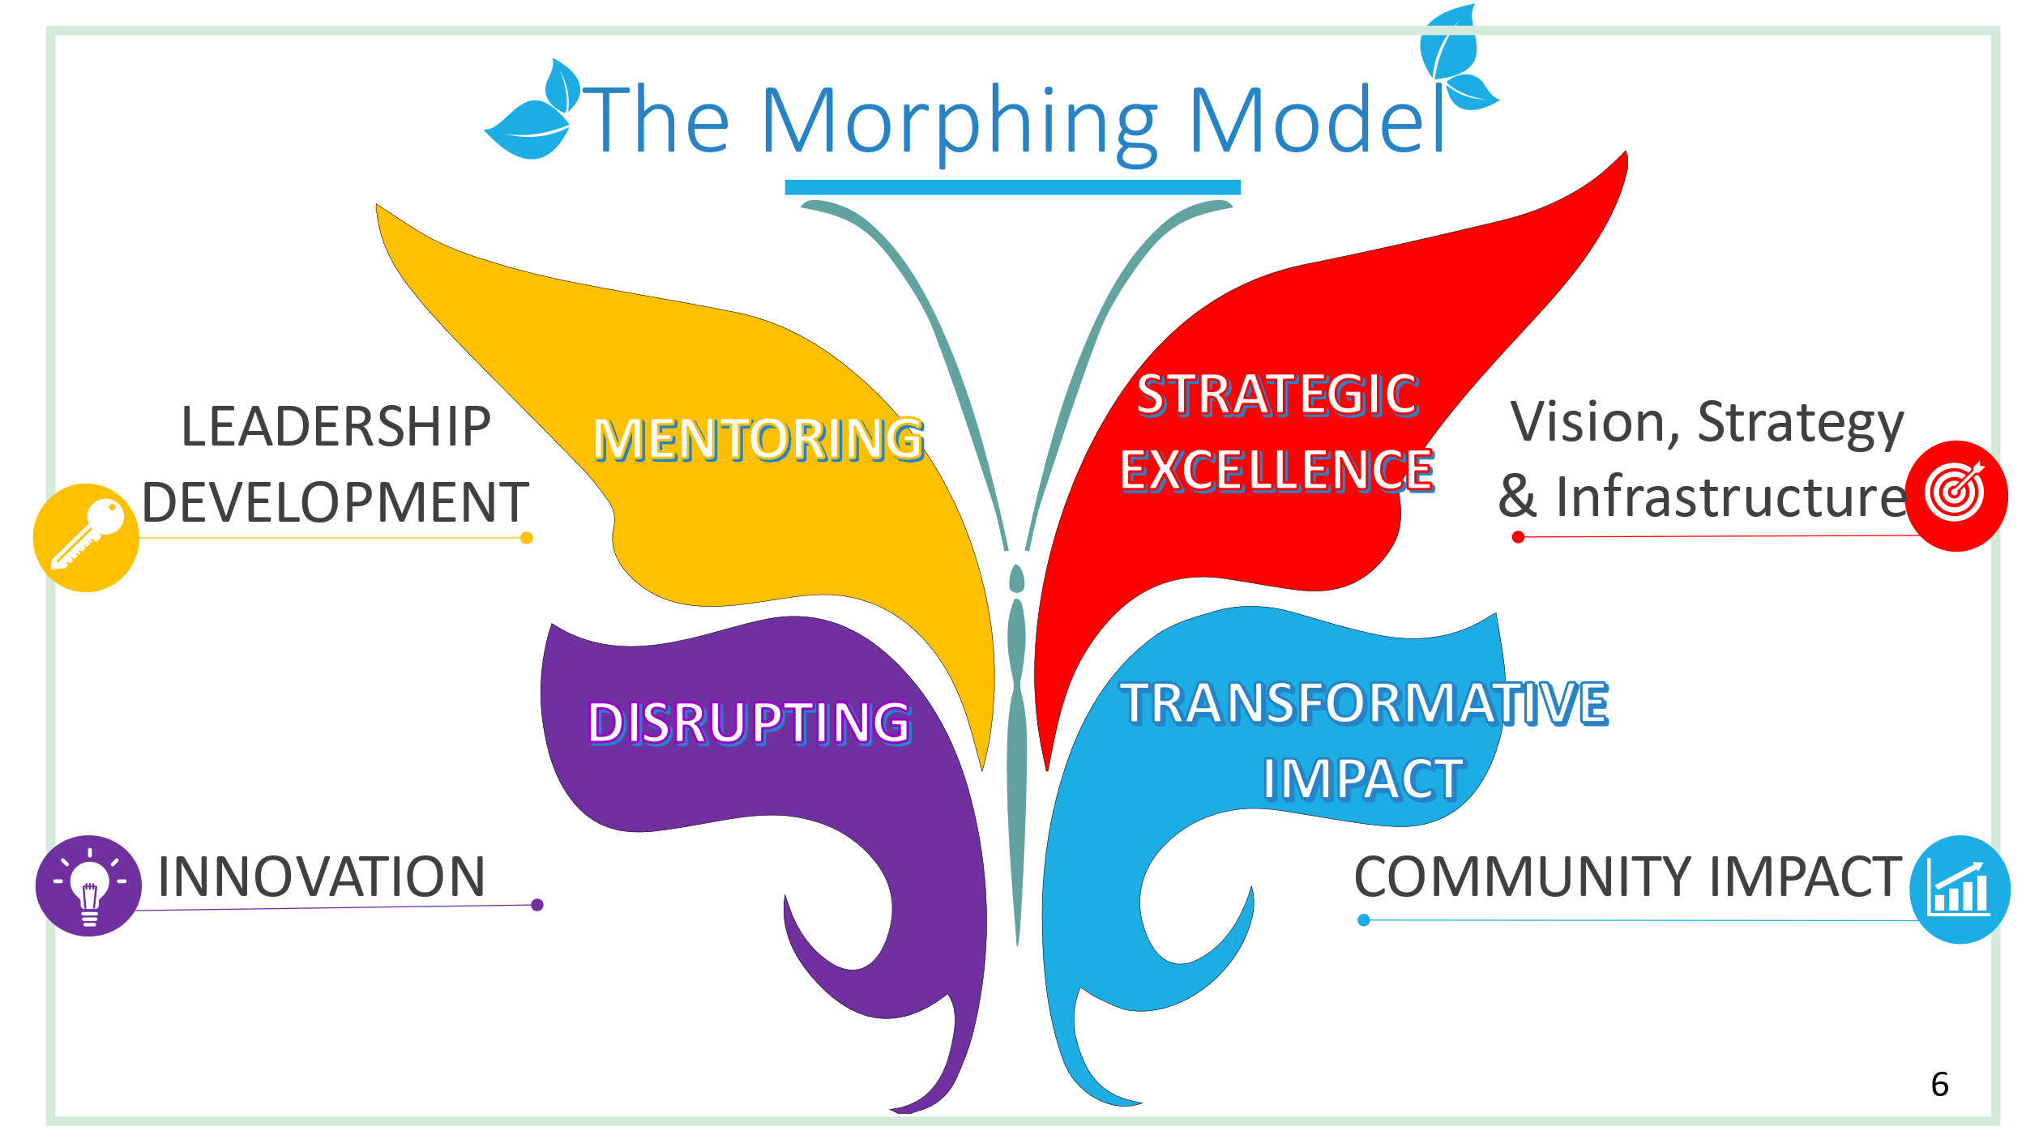design.

The Morphing Model has four key components that focus on the leader's ability to innovate, share leadership, develop other leaders, and provide strategic vision and infrastructure for the team and the individual's success. Together these components drive the results that lead to transformative community impact. The pieces are interdependent, and without one, the others will not have the effect they can have on the leader's objectives and the organization's mission.

The Habits of the Mind are infused throughout the model. It calls for what Sommers and Zimmerman call "keeping hope alive." The acronym HOPE stands for humility ( remaining open to learning), options ( thinking flexibility, listening, and creating), persistence (passion for learning and performance), and everyone ( thinking independently) ( 2008, p.314). The model creates a consistent culture of altruism focused on helping and supporting others while allowing a pragmatic process to innovate and pilot solutions that significantly impact their lives.

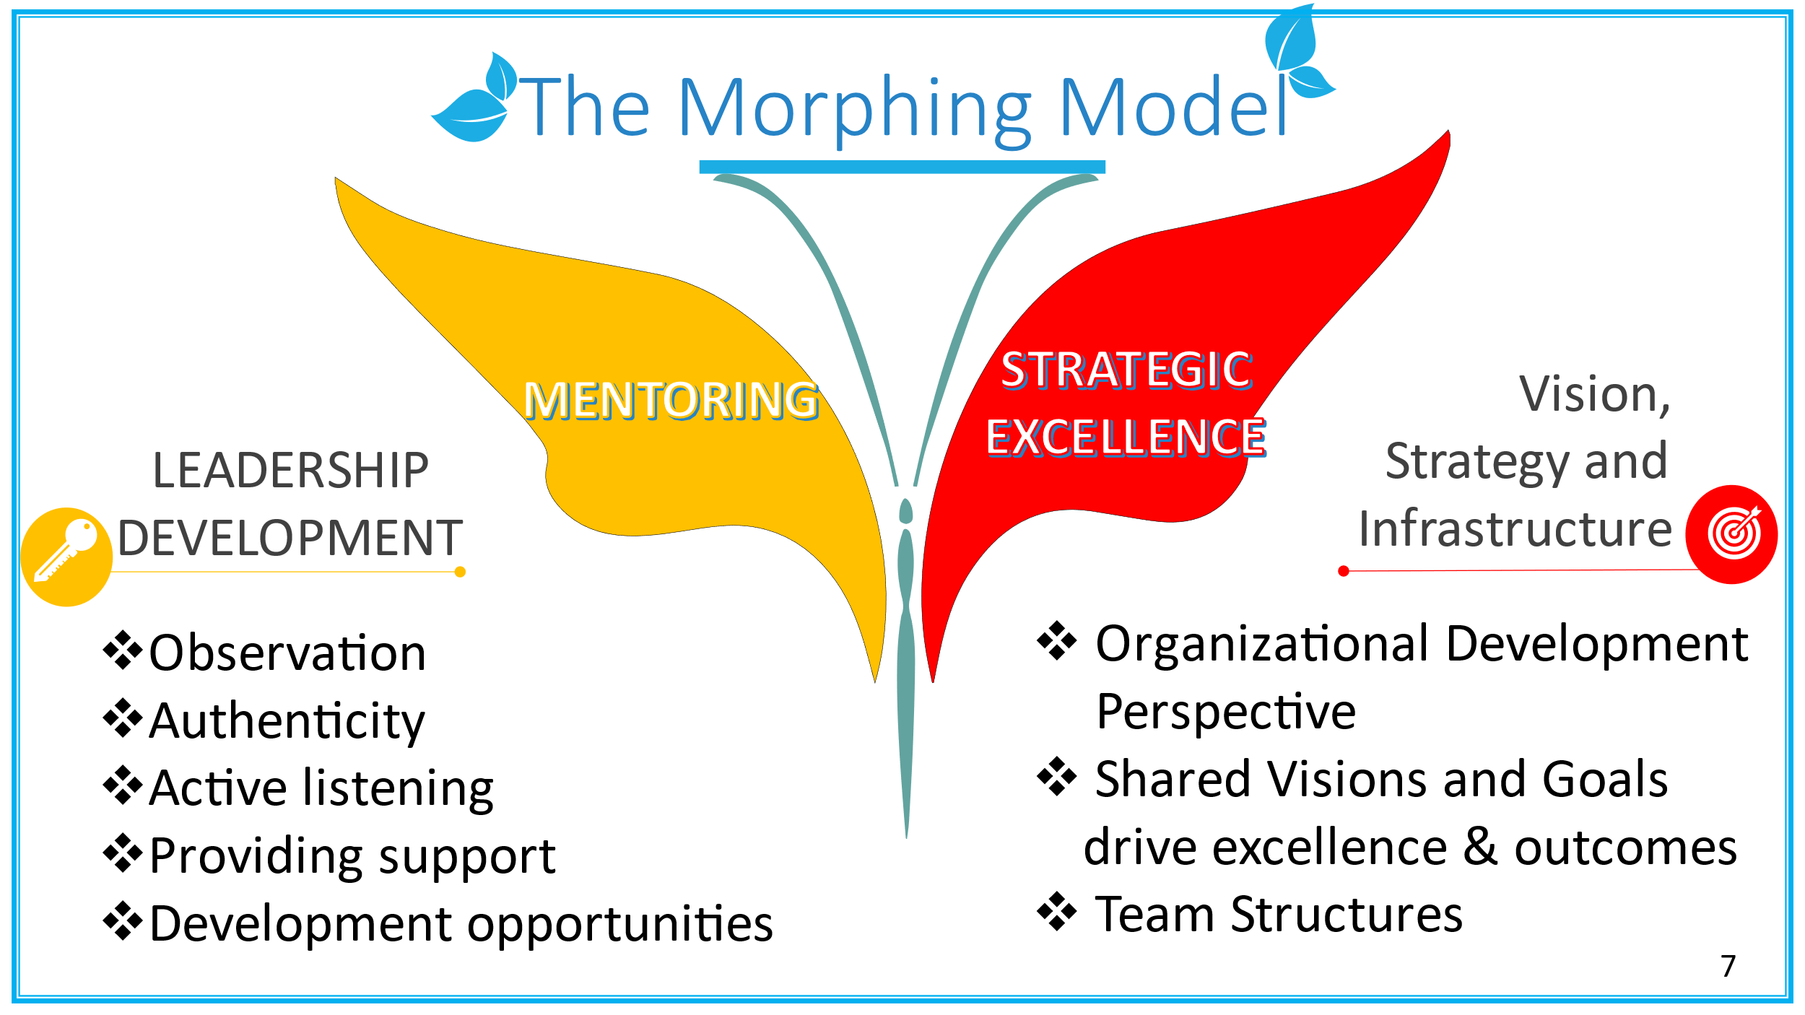The ***Mentoring*** component focuses on helping others tap into their potential. The mentor needs to show up ready to learn and be vulnerable, not to teach. Using observation skills, listening with empathy, and providing guidance and support as needed will help the employees/followers identify leadership development opportunities. This process is most effective when the leadership exhibits an authentic leadership style and transformative leadership behaviors.

The ***Strategic Excellence*** component is built on transformative and shared leadership styles. The leader is responsible for creating inspirational visions and strategic goals that drive performance and excellence. These team structures built on shared and collaborative styles increase the team members' motivation to help one another and take on leadership roles to contribute ideas and expertise (Karriker et al., 2017).

The ***Disrupting*** component is built on the two key behaviors innovators tap into most to connect the dots and develop innovative solutions; observation and networking. Leaders must have a bench of experts from different fields, disciplines, and professions to build a different perspective and understanding of how they approach challenges and resolve significant issues. That knowledge can then create a library of approaches that the leader can consider when analyzing a problem and seeking solutions. This component is where dramatic rehearsal and 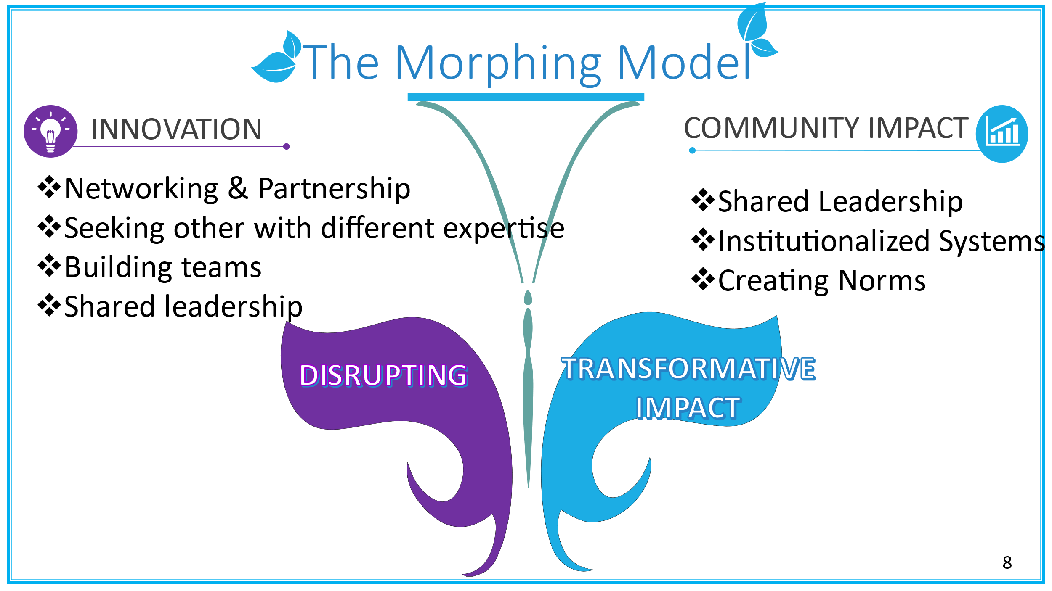piloting would occur to test the moral and solution efficacy. It is also the component that allows for practicing mental models and developing expertise.

The ***Transformative Impact*** component focuses on collective and collaborative teams and partnerships that implement innovative solutions. This united support and expertise takes innovative solutions and creates systems that develop collective norms and institutionalize new practices. In order to have a long-term impact on the individuals you are helping, the community must be engaged in implementing the solution. This process also helps create a culture of altruism, both in the organization and the community, teaching everyone involved to support others in their time of need. This authenticity in value and practice allows for self-regulation and self-awareness.

**Conclusion**

In the past 20 years, organizations and communities have continuously dealt with uncertainties, making it more complex and even less predictable to anticipate what challenges may be on the horizon. Boulton et al. (2015) describe uncertainty as that which can not be known, the "unknown unknowns" (p. 214). For communities to tackle the complex challenges that negatively impact their residents, they need community and organizational leaders that engage with the world's complexities with curiosity, shared leadership, and collective learning. It is no longer reasonable for leaders to focus on past patterns and organizational history to frame future solutions. Instead, leaders need to consider the events that disrupt stability and employ recombination of resources and practices to create emergent practices necessary to be responsive and sustain the organization's services, business constructs, and community norms that best lift its residents to face unpredictable and, at times, unimaginable adversities.

**References:**

Ashford, S., & DeRue, D. (2012). Developing as a leader. Organizational Dynamics, 41(2), 146 154

Bryman, A., Collison, D., Grint, K., Jackson, B. & Uhl-Bien, M. (2011). Leadership Development. The Sage Handbooks of Leadership. London, England: Sage Publications Ltd. ISBN-13:978-1-84860-146-8.

Bryman, A., Collison, D., Grint, K., Jackson, B. & Uhl-Bien, M. (2011). Leadership Ethics. The Sage Handbooks of Leadership. London, England: Sage Publications Ltd. ISBN-13:978 1-84860-146-8.

Bryman, A., Collison, D., Grint, K., Jackson, B. & Uhl-Bien, M. (2011). Transformational Leadership. The Sage Handbooks of Leadership. London, England: Sage Publications Ltd. ISBN-13:978-1-84860 146-8.

Bryman, A., Collison, D., Grint, K., Jackson, B. & Uhl-Bien, M. (2011). Team Leadership: A Review and Look Ahead. The Sage Handbooks of Leadership. London, England: Sage Publications Ltd. ISBN 13:978-1-84860-146-8.

Costa, A (2008) Describing the habits of mind. Chapter 2 In Kallick, B., and Costa, A., (Eds) Learning and leading with habits of mind: 16 Essential characteristics for success. ASCD.

Day, D., Harrison, M., & Halpin, S. (2008) An integrative approach to leader development: Connecting adult development, identity, and expertise New York, NY: Routledge ISBN: 978-041596462-3

Dyer, J., Gregersen, H., & Christensen, C. (2009). The Innovator's DNA. (cover story). Harvard Business Review, 87(12), 60–67.

Gardner, H., &Laskin, E.,(2013). *Leading minds: An anatomy of leadership* (paperback reprint edition.) New York: Basic Books, Perseus Books Group.

Horstmeyer, A. (2020). The generative role of curiosity in soft skills development for contemporary VUCA environments. *Journal of Organizational Change Management,* *33(5),* 737-751.

Karriker, J., Madden, L., & Katell, L. (2017). Team composition, distributed leadership, and performance: It's good to share. Journal of Leadership & Organizational Studies, 24(4), 507-518.

Moynihan, D., Pandey, S, and Wright, B (2012). Setting the table: How transformational leadership fosters performance information use. Journal of Public Administration Research and Theory, 22,(1), Pages 143–164, https://doi.org/10.1093/jopart/mur024

Pesut, D. (2019). Anticipating Disruptive Innovations with Foresight Leadership. *Nursing* *Administration Quarterly,* *43(3),* 196–204.

Sommers, W., and Zimmerman, D. (2008). Leading is a habit of mind. Chapter 17 in Kallick, B., and Costa, A., (Eds) Learning and leading with habits of mind:16 Essential characteristics for success. ASCD.

Tichy, N. M., & Bennis, W. G. (2009). *Judgment: How Winning Leaders Make Great Calls* (Updated ed. edition). New York: Portfolio.